OUTRAGEOUS HAIR STYLE CONTEST
Stylish Woman Expo Registration Form
RULES & REGULATONS

CONTEST HOUR: 10 AM – 12 PM JUDGING 12 PM – 1 PM AWARD CEREMONY 5:15 PM

Contestant’s:
Registration: $25 per contestant. Must bring own products & supplies to work with.
Will receive two competition admissions. Cannot leave contest area during competition.
Must be 18 years or older. Model must be present for prize ceremony.
Are allowed one model Contest time is two hour
Must be present to setup 30 minutes prior to contest.
Contest deadline: 8.8.22 or when all positions are filled.
Will be judged by public vote one hour after competition.
No jewelry or other markings allowed from neck up during this competition.
o Design o Originality & Creativity o Degree of difficulty o Color o Finished quality & neatness.
Will follow all guidelines, directions and management decisions or may loss his/her place in competition.
Contestant may represent themselves or by the company they represent (Limit 3 to company entrée).
Stylish Woman Expo (SWE) reserves all rights to this contest and is subject to make any changes necessary.
1ST PRIZE $500

2ND PRIZE $200
3RD PRIZE $100
PLUS
3 HONORABLE MENTIONS
Gift Prizes
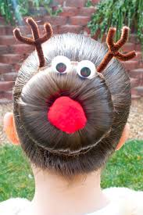
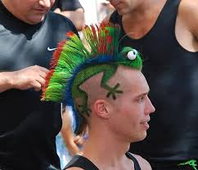
Come join the fun and see if you can create a unique hairstyle one can imagine. This competition will be judged by the SWE attendees as to who will have the most outrageous hairstyle. Anyone can qualify over the age of 18 years old to win some of our great prizes.
Contestant |  | Position
Email address |  | Cellular
Representing |  | Date
Stylish Woman Expo
Reno-Sparks Convention Center
September 10, 2022
Saturday 9 AM – 6 PM

I AGREE to the terms & conditions of this Outrageous Hair Contest. I have completed the information above and enclosed is my $25 registration fee. I understand SWE reserves all rights to this event.

Signature |  | Date
REVISED: 1.6.22

More information about this event
festivalofshows.com

Email your application to:
Allen@festivalofshows.com
775.895.2912

REGISTRATION $25
SPACE IS LIMITED

