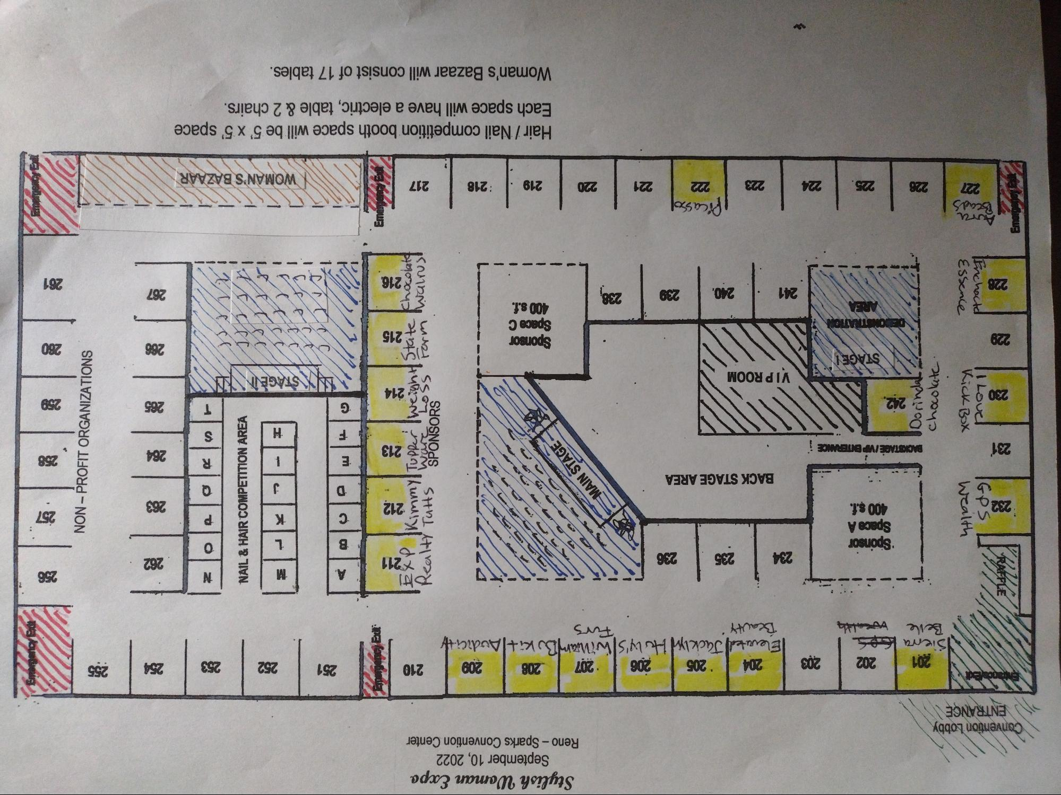
Stylish Woman Expo
September 10, 2022 Reno - Sparks Convention Center
Convention Lobby
ENTRANCE
203
210
251
201 Sierra Belle
202 GPS wealth
204 205 206 207 208 209 Elevated Beauty Jacklyn Huly's William Bukit/
Audacity Beauty
.
---
262
TEPS. Wealth
Sponsor Space A 400 ş.f.
265
MAIN STAGE-T
BACK STAGE AREA
NAIL & HAIR COMPETITION AREA
264
BACKSTAGE/WPENERANCE
Realty Tutts SPONSORS Exp Realty Kimmy Tatts Tupperware
State Farm

Chocolate Walrus
wairust
chocolate 3 Dorinda
NON-PROFIT ORGANIZATIONS
I Love Kick Box
285
VIP ROOM
A STAGĚ 1
STAGE
266
DE NOTRATION
Sponsor Space C 400 s.f.
241
enchanted Essence
240.
239
281
Aurubeads
Picasso
Beads
227
Ement
228
25.
223
222
221
220
219
218
217
Emergency Ex
WOMAN'S BAZAAR
Hair/Nail competition booth space will be 5' x 5' space Each space will have a electric, table & 2 chairs. Woman's Bazaar will consist of 17 tables.

